ASSIGNMENT

1. Checking the data preparation form the data set given

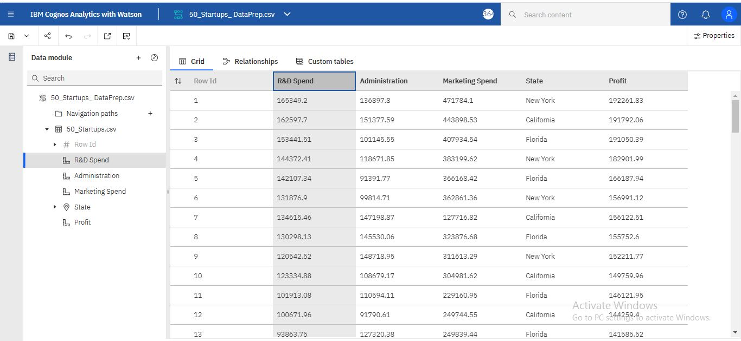

1. Explore data relationships

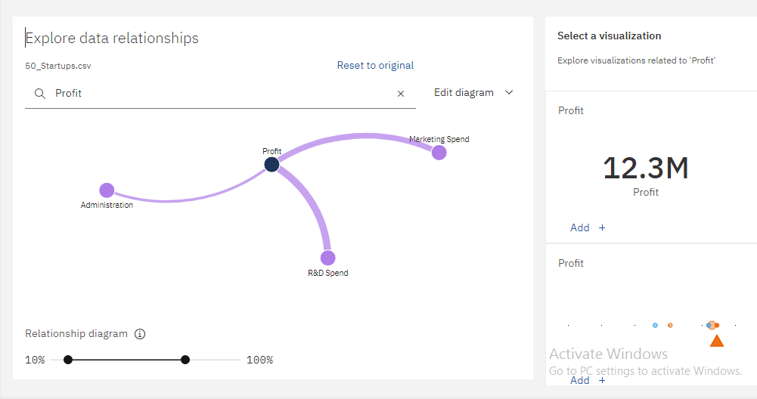

1. Visualizing the given dataset

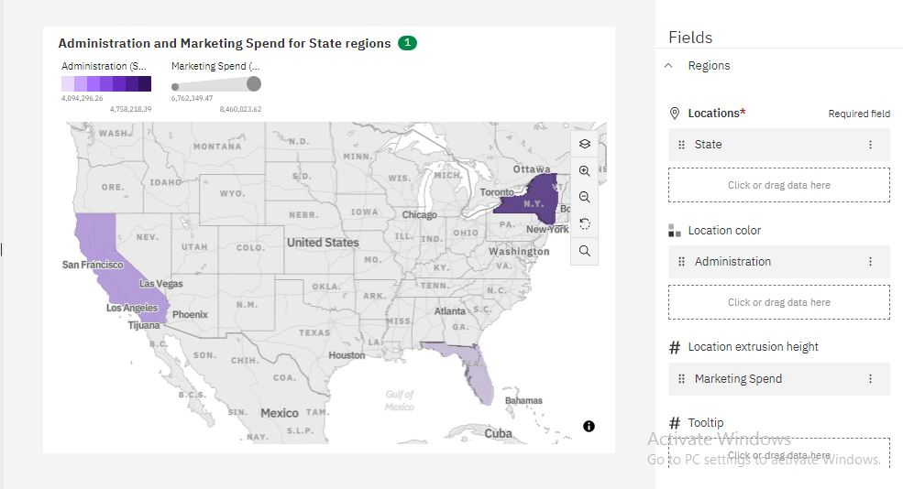

1. 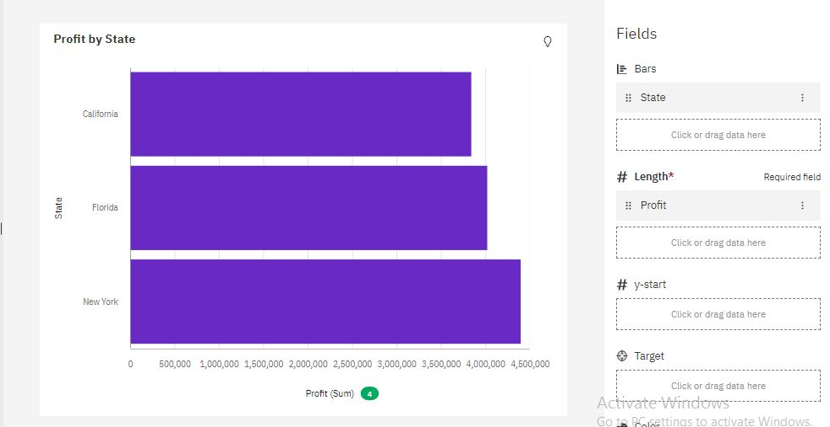Bar chart (Profit by State)

1. Pie Chart(R&D Spend by State)

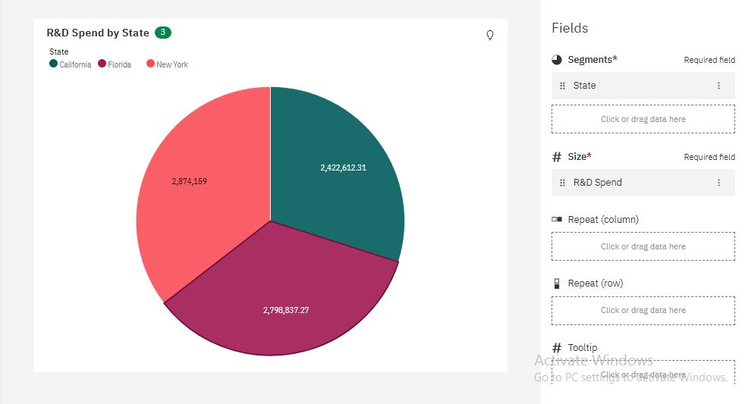

1. Radial Chart (Administration by State)

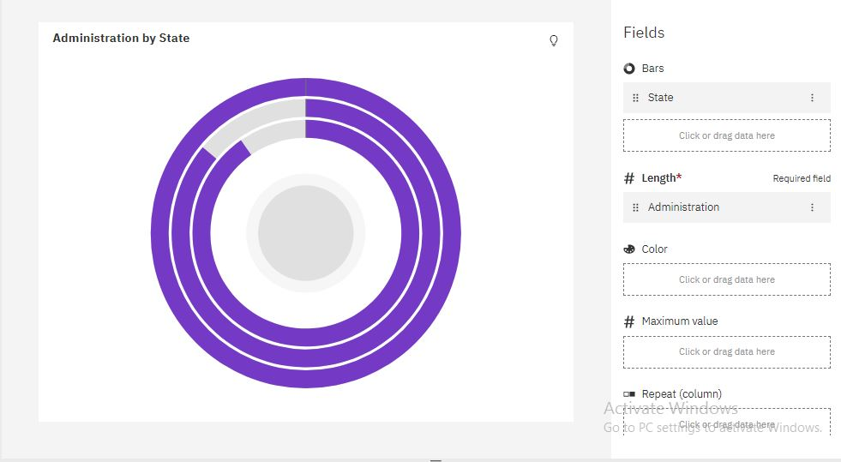

1. Area Chart (Marketing Spend by State)

